**ERP System for a Mini Manufacturing Company**

1. Introduction

1.1 Objective

The objective of this project is to design and implement a comprehensive ERP (Enterprise Resource Planning) system specifically tailored for a mini manufacturing company. The ERP system aims to integrate various business processes across different departments, including inventory management, production planning, sales and order processing, purchasing, finance, human resources, and reporting. By consolidating these functions into a single, unified platform, the ERP system will enable the company to achieve the following:

1. **Improve Operational Efficiency**: Streamline workflows across all departments to reduce manual tasks, minimize errors, and enhance productivity. Automating routine processes, such as order processing, inventory tracking, and financial reporting, will free up employees' time for more strategic activities.
2. **Enhance Data Accuracy and Visibility**: Centralize data from various business functions into one platform, ensuring that all departments work with consistent and accurate information. This integrated approach will provide real-time visibility into key business metrics, enabling informed decision-making and timely interventions.
3. **Optimize Inventory Management**: Implement robust inventory management capabilities to track stock levels in real time, manage reorder points, and reduce carrying costs. Accurate inventory data will help the company minimize stockouts and overstock situations, thereby improving customer satisfaction and reducing waste.
4. **Improve Production Planning and Control**: Provide tools for efficient production scheduling, resource allocation, and quality control. By optimizing production processes, the company can increase output, reduce downtime, and ensure that products are manufactured to the highest quality standards.
5. **Strengthen Financial Management**: Integrate finance and accounting functions to automate financial transactions, streamline reporting, and ensure compliance with accounting standards. Real-time access to financial data will enhance budgeting, forecasting, and financial analysis, supporting better financial management and planning.
6. **Enhance Sales and Customer Relationship Management**: Facilitate efficient order processing, invoicing, and customer management. By improving sales processes and providing better customer service, the company can increase sales, retain customers, and build stronger relationships with clients.
7. **Streamline Purchasing and Supplier Management**: Implement a streamlined purchasing process that ensures timely procurement of materials, manages supplier relationships effectively, and controls costs. By optimizing the purchasing function, the company can maintain strong supplier partnerships and ensure the continuous availability of raw materials.
8. **Support Human Resource Management**: Provide comprehensive tools for managing employee records, payroll, attendance, and performance. A well-organized HR module will help the company manage its workforce more effectively, improve employee satisfaction, and support strategic HR initiatives.
9. **Facilitate Data-Driven Decision Making**: Enable the generation of customized reports and dashboards that provide insights into various aspects of the business. By leveraging data analytics, the company can monitor performance, identify trends, and make data-driven decisions to drive growth and profitability.
10. **Ensure Scalability and Future Growth**: Design the ERP system to be scalable and flexible, allowing the company to add new modules and functionalities as it grows. A scalable system will support the company’s long-term objectives and adapt to changing business needs.

**2.3 Modules Included**

1. Inventory Management :

Inventory management is critical for manufacturers and distributors, and manufacturing ERP and distribution ERP software is designed to facilitate easy inventory management. An ERP system can provide real-time visibility into inventory levels, allowing the manufacturing company to track the movement of raw materials, work-in-progress, and finished goods. Many ERP solutions make it easy to seamlessly integrate inventory management and tracking technologies such as RFID inventory tracking.

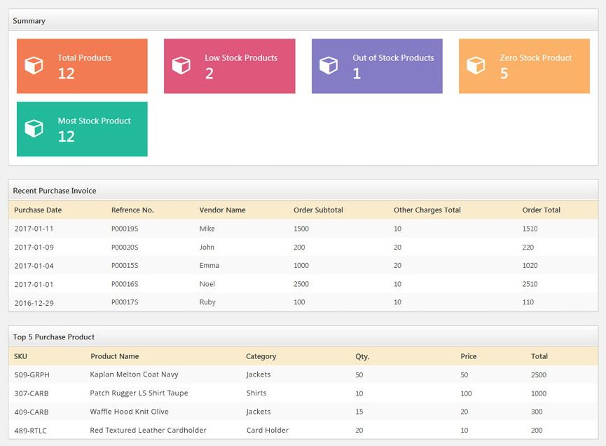

2. Production Planning and Control :

The Production Planning and Control module is designed to manage and optimize the manufacturing processes of the mini manufacturing company. This module helps in planning production schedules, allocating resources, tracking production progress, and ensuring quality control. It provides real-time visibility into the production floor, enabling efficient use of resources, reducing lead times, and ensuring that production targets are met.

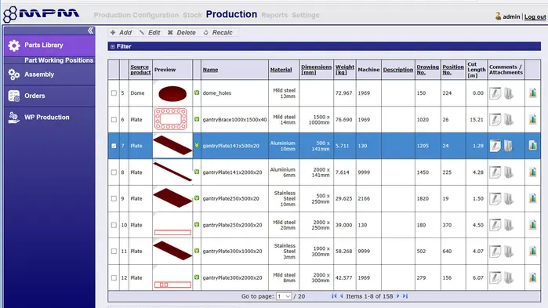

3. Sales and Order Processing :

The **Sales and Order Processing** module is designed to manage and automate the end-to-end sales process, from capturing customer orders to invoicing and tracking sales performance. This module helps streamline order management, reduce manual errors, and improve customer satisfaction by providing a centralized platform for all sales activities.

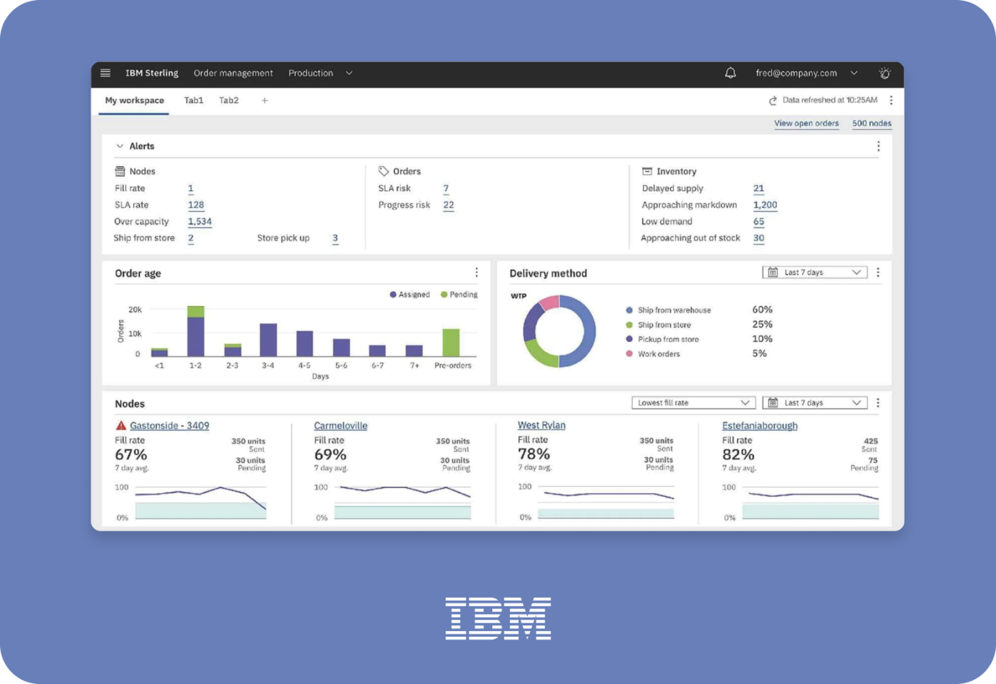

4. Purchasing and Supplier Management :

The **Purchasing and Supplier Management** module is designed to automate and streamline the procurement process, from supplier management to purchase order creation and tracking. This module helps ensure that the company has the necessary materials and supplies to maintain production efficiency while optimizing costs and managing supplier relationships effectively.

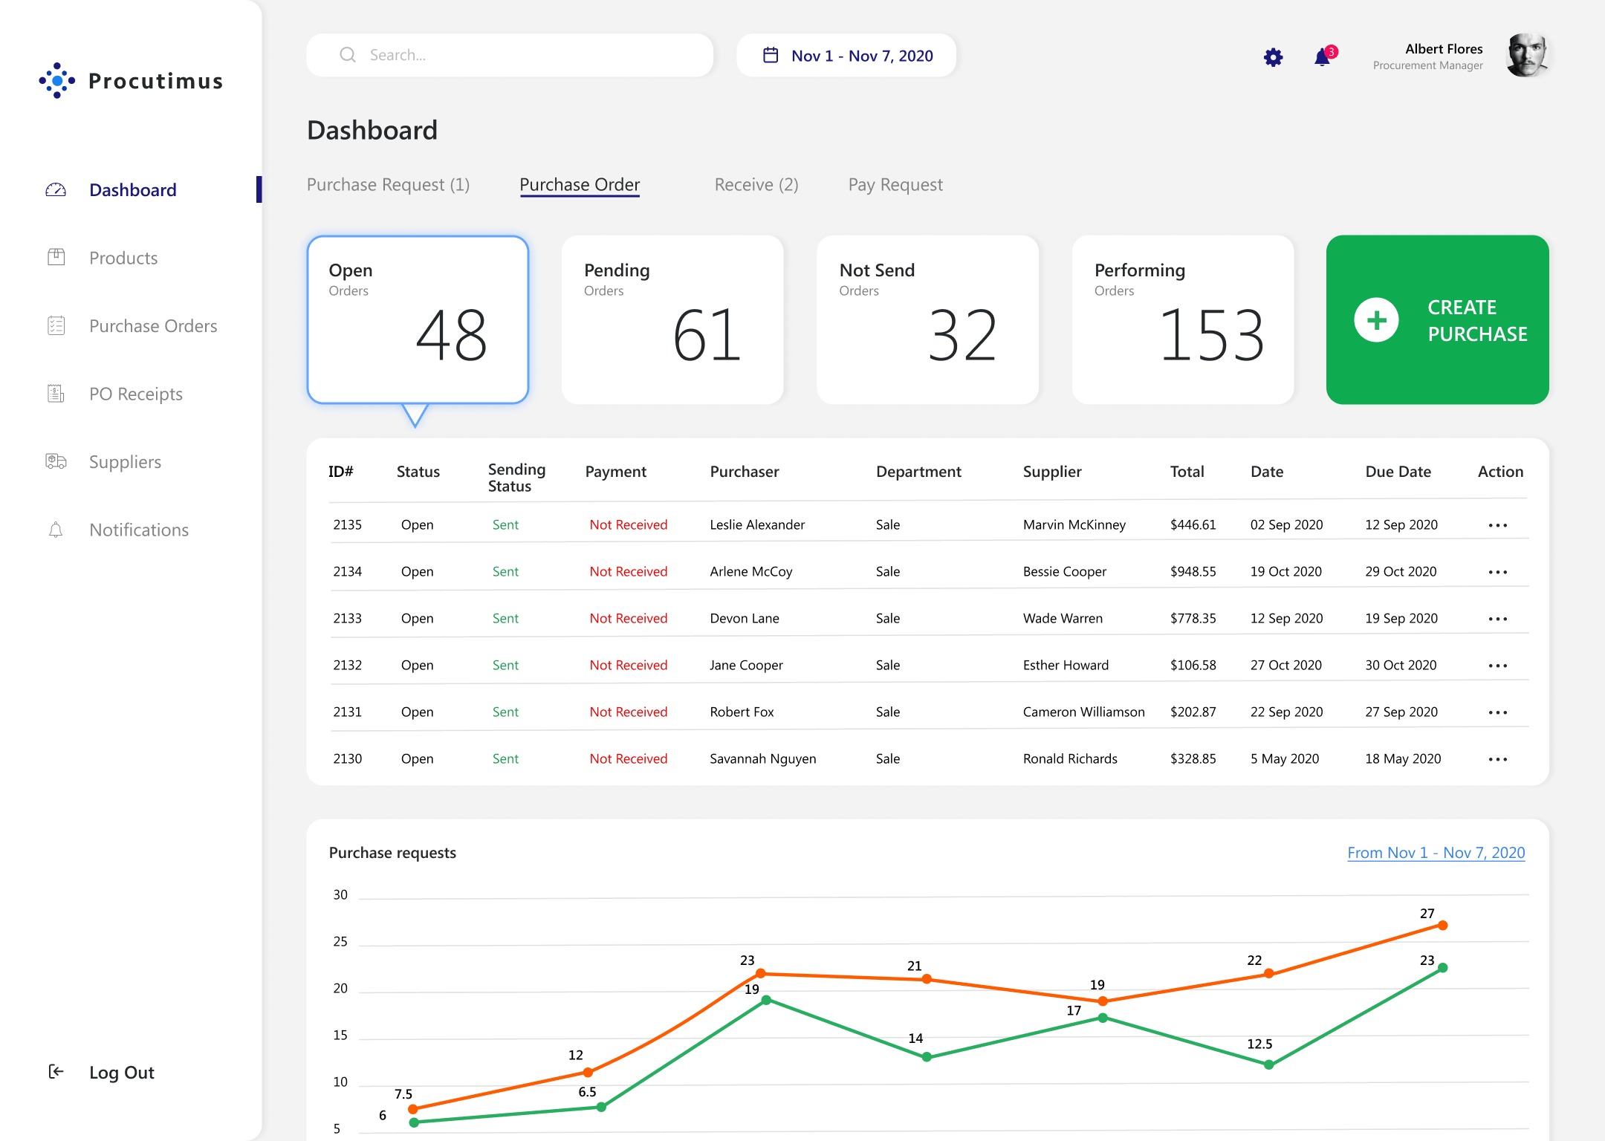

5. Finance and Accounting :

An ERP system makes it easier for businesses to keep detailed and accurate accounting records. Accounts payable and receivable can often be automatically tracked and synced, and tax bookkeeping can be done automatically, reducing the risk of human error.

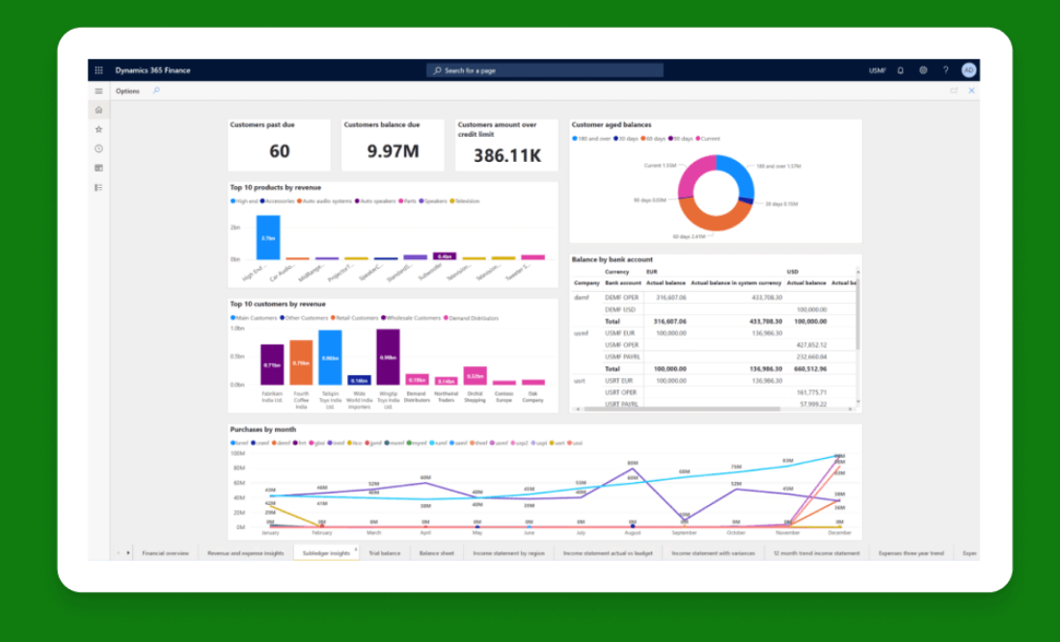

6. Human Resources Management :

The systems now frequently include human resources modules that allow businesses to track and manage their labor allocation, employee benefits, and staff training.

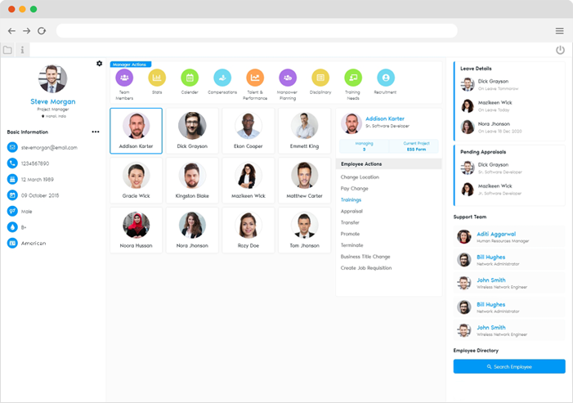

3. System Requirements

**1. Hardware Requirements**

**1.1. Server Requirements**

The ERP system requires a dedicated server to host the application and database. The specifications depend on the size of the organization, the number of users, and the volume of transactions. Below are the recommended minimum and optimal requirements:

* **Processor**:
  + Minimum: Quad-core 2.5 GHz
  + Optimal: Octa-core 3.0 GHz or higher
* **RAM**:
  + Minimum: 16 GB
  + Optimal: 32 GB or higher
* **Storage**:
  + Minimum: 500 GB SSD
  + Optimal: 1 TB SSD or higher (with RAID configuration for redundancy)
* **Network**:
  + Minimum: 1 Gbps Ethernet adapter
  + Optimal: 10 Gbps Ethernet adapter
* **Backup Solution**:
  + Regular automated backups are required. An external storage solution or cloud-based backup service is recommended for redundancy.

**1.2. Client Workstation Requirements**

The client workstations are the end-user machines that interact with the ERP system. The requirements for these machines are typically lower than those of the server but still need to be sufficient to handle the ERP software's interface and processing demands.

* **Processor**:
  + Minimum: Dual-core 2.0 GHz
  + Optimal: Quad-core 2.5 GHz or higher
* **RAM**:
  + Minimum: 4 GB
  + Optimal: 8 GB or higher
* **Storage**:
  + Minimum: 128 GB HDD/SSD
  + Optimal: 256 GB SSD or higher
* **Display**:
  + Minimum: 1024x768 resolution
  + Optimal: Full HD 1920x1080 resolution
* **Operating System**:
  + Windows 10 or later, macOS 10.15 (Catalina) or later, or any supported Linux distribution

**2. Software Requirements**

**2.1. Server Software Requirements**

The server must have the appropriate operating system and software installed to run the ERP application and database. The requirements vary depending on the specific ERP software chosen.

* **Operating System**:
  + Windows Server 2016 or later
  + Linux (e.g., Ubuntu Server 20.04 LTS, CentOS 8)
* **Database Management System (DBMS)**:
  + SQL Server 2017 or later
  + MySQL 8.0 or later
  + PostgreSQL 12 or later
  + Oracle Database 19c or later
* **Web Server**:
  + Apache HTTP Server 2.4 or later
  + Microsoft IIS 10 or later
  + Nginx 1.18 or later
* **ERP Application**:
  + The specific ERP software (e.g., SAP, Microsoft Dynamics, Oracle ERP, Odoo) and its dependencies
* **Middleware**:
  + .NET Framework (if required by ERP software)
  + Java Runtime Environment (JRE) 8 or later (if required by ERP software)

**2.2. Client Software Requirements**

Client workstations need specific software to access the ERP system. This includes web browsers, office suites, and sometimes additional software provided by the ERP vendor.

* **Web Browser**:
  + Google Chrome (latest version)
  + Mozilla Firefox (latest version)
  + Microsoft Edge (latest version)
  + Safari (latest version)
* **Office Suite**:
  + Microsoft Office 2016 or later
  + LibreOffice 6.4 or later (for Linux users)
* **Additional Software**:
  + ERP-specific client software or plug-ins as required

**4.1 Architecture Overview**

The architecture of the ERP (Enterprise Resource Planning) system for a mini manufacturing company is designed to provide a scalable, flexible, and secure solution that integrates various business processes into a single unified platform. This architecture is structured to ensure efficient data flow, robust performance, and seamless integration with existing systems.

#### ****1. Architectural Layers****

The ERP system is structured into several layers, each serving a specific purpose and facilitating modularity, maintainability, and scalability. The main architectural layers include:

1. **Presentation Layer**
2. **Application Layer**
3. **Data Layer**
4. **Integration Layer**

##### ****1.1. Presentation Layer****

The **Presentation Layer** is the topmost layer of the ERP architecture. It serves as the user interface, allowing users to interact with the system through web browsers, desktop applications, or mobile apps. The key components of this layer include:

* **User Interface (UI)**: Provides a graphical interface for users to interact with the ERP system. The UI is designed to be intuitive, user-friendly, and accessible on various devices, including desktops, tablets, and smartphones.
* **User Experience (UX)**: Focuses on the overall experience of users when navigating the ERP system. The design ensures ease of use, with streamlined workflows and a consistent look and feel across different modules.

##### ****1.2. Application Layer****

The **Application Layer** contains the core business logic and functionalities of the ERP system. It processes user requests, performs business operations, and manages transactions. This layer is divided into multiple modules, each responsible for a specific business function:

* **Inventory Management Module**: Manages all aspects of inventory control, including stock levels, reorder points, and inventory valuation.
* **Production Planning and Control Module**: Handles production scheduling, work order management, and quality control processes.
* **Sales and Order Processing Module**: Manages customer orders, invoicing, and sales analytics.
* **Purchasing and Supplier Management Module**: Facilitates procurement processes, supplier management, and purchase order tracking.
* **Finance and Accounting Module**: Manages financial transactions, including general ledger, accounts payable and receivable, and financial reporting.
* **Human Resources Management Module**: Handles employee records, payroll, recruitment, and performance management.
* **Reporting and Analytics Module**: Provides data analytics and reporting capabilities to support decision-making.

The Application Layer is designed to be modular, allowing for easy addition or modification of features and functionalities without affecting the overall system.

##### ****1.3. Data Layer****

The **Data Layer** is responsible for data storage, management, and retrieval. It ensures data consistency, integrity, and security across the ERP system. This layer comprises:

* **Database Management System (DBMS)**: The DBMS stores all data related to the ERP system, including master data, transactional data, and metadata. Popular DBMS options include Microsoft SQL Server, MySQL, PostgreSQL, and Oracle Database.
* **Data Access Layer (DAL)**: This sub-layer provides an abstraction between the application layer and the database, ensuring that the application interacts with the database in a consistent manner. The DAL handles all CRUD (Create, Read, Update, Delete) operations, database connections, and query executions.

##### ****1.4. Integration Layer****

The **Integration Layer** facilitates seamless communication and data exchange between the ERP system and external systems, such as third-party applications, legacy systems, and external data sources. This layer includes:

* **Application Programming Interfaces (APIs)**: APIs enable secure and standardized communication between the ERP system and external applications. They support various protocols such as REST, SOAP, and GraphQL.
* **Middleware**: Middleware acts as a bridge between different software applications, enabling data integration, transformation, and orchestration across multiple systems. It can include message brokers, ETL (Extract, Transform, Load) tools, and integration platforms like MuleSoft or Apache Camel.
* **Data Connectors**: These are pre-built interfaces that facilitate data exchange between the ERP system and specific third-party applications, such as e-commerce platforms, CRM systems, or financial software.

#### ****2. Deployment Architecture****

The ERP system can be deployed in various configurations, depending on the organization's needs, budget, and technical capabilities. The main deployment options are:

##### ****2.1. On-Premises Deployment****

In an **On-Premises Deployment**, the ERP system is hosted on the company’s own servers and managed by the in-house IT team. This option provides greater control over data security and system customization but requires significant upfront investment in hardware and ongoing maintenance.

##### ****2.2. Cloud-Based Deployment****

A **Cloud-Based Deployment** hosts the ERP system on cloud servers managed by a third-party provider. This option offers scalability, flexibility, and reduced IT overhead, as the provider handles infrastructure management, updates, and backups. Cloud-based ERP systems can be deployed on public, private, or hybrid cloud environments.

##### ****2.3. Hybrid Deployment****

**Hybrid Deployment** combines on-premises and cloud-based deployment models. Certain modules or data may be hosted on-premises for security or compliance reasons, while other components are hosted in the cloud for scalability and ease of access. This model provides a balance between control and flexibility.

#### ****3. Security Architecture****

The security architecture of the ERP system is designed to protect sensitive business data and ensure compliance with regulatory standards. Key components of the security architecture include:

* **Authentication and Authorization**: Implement multi-factor authentication (MFA) and role-based access control (RBAC) to ensure that only authorized users have access to specific functions and data.
* **Data Encryption**: Use encryption protocols such as SSL/TLS for data in transit and AES for data at rest to protect sensitive information from unauthorized access.
* **Audit Logging**: Maintain detailed logs of user activities, system changes, and access events to support security monitoring, auditing, and compliance requirements.
* **Firewall and Intrusion Detection**: Deploy firewalls and intrusion detection/prevention systems (IDPS) to protect the ERP system from external threats and unauthorized access.
* **Regular Security Audits**: Conduct regular security audits and vulnerability assessments to identify and address potential security risks.

**7. Functional Prototype**

7.1 Tableau Dashboard

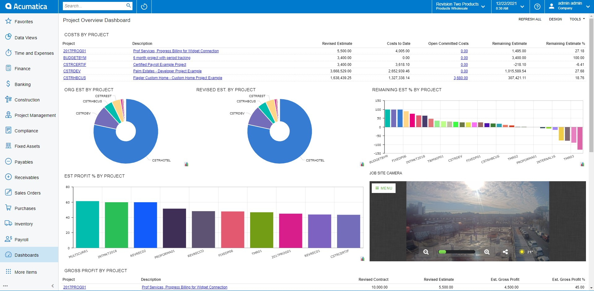

8. Implementation Plan

The implementation plan for the ERP system is to ensure a smooth transition, minimize disruptions, and maximize the system's effectiveness. This brief plan outlines the key phases and steps involved in deploying the ERP system.

**1. Planning and Preparation**

* **Project Kickoff**: Establish a project team, define project scope, objectives, and timelines.
* **Requirements Gathering**: Identify and document all business requirements and processes.
* **System Selection**: Choose the ERP software that best fits the company's needs.
* **Risk Assessment**: Identify potential risks and develop mitigation strategies.

**2. System Design and Configuration**

* **System Design**: Design the architecture, including hardware, software, and network requirements.
* **Customization**: Configure the ERP system according to the company’s specific processes and workflows.
* **Data Migration Plan**: Develop a strategy for migrating existing data into the new ERP system.

**3. Development and Testing**

* **Data Migration**: Extract, transform, and load (ETL) existing data into the ERP system.
* **Integration**: Integrate the ERP system with existing applications and external systems.
* **Testing**: Conduct unit testing, system testing, and user acceptance testing (UAT) to ensure the system functions as expected.

**4. Training and Change Management**

* **User Training**: Provide training sessions for end-users and administrators on using the ERP system effectively.
* **Documentation**: Develop user manuals, quick reference guides, and system documentation.
* **Change Management**: Implement a change management plan to manage organizational change and encourage user adoption.

**5. Go-Live and Deployment**

* **Final Data Migration**: Perform final data migration, ensuring all data is accurate and complete.
* **Go-Live Preparation**: Set up production environments and ensure all systems are ready for deployment.
* **Go-Live**: Launch the ERP system, providing support for any issues that arise.

**6. Post-Implementation Support**

* **Monitoring and Support**: Monitor the system’s performance and provide technical support to users.
* **Performance Optimization**: Make any necessary adjustments to optimize the system’s performance.
* **Continuous Improvement**: Gather feedback from users and make iterative improvements to the system.